MEDILINK HEALTH NETWORK
INTEGRATED ENTERPRISE DATA MANAGEMENT STRATEGY
Enterprise Data Platform Capstone Project
Course: Enterprise Data Management
Programme: Bachelor of Information Technology
Institution: Kampala International University

Group members
Group 1
S/N | Name | Registration No. | Role | Signature
1 | KASIMAGWA STEVEN | 2024-08-29341 | IT Custodian
2 | RWOTHONGEYO MARK | 2024-08-30835 | Analyst
3 | AHAIRWE APOPHIA | 2024-08-31393 | Data Steward
4 | BALABA CHARLES MOSES | 2024-08-29007 | Data Steward
5 | MUSIMBI AARON | 2024-08-28258 | Documenter

Lecturer: Mr Niyibizi Kenneth

Submission date: 2026-10-12

Contents
1. Executive Summary
2. Business Context and Objectives
3. Governance and Accountability
4. Architecture and Data Model
5. Data Quality Management
6. Master Data Management
7. Metadata, Cataloguing and Lineage
8. Security, Privacy and Compliance
9. Analytics and Ministry of Health Reporting
10. Implementation Roadmap and Future Development
11. Operations, Monitoring and Risk Management
12. Conclusion
Appendix A. Database Objects Referenced in the Design
Appendix B. Individual Reflection and Contribution Log

1. Executive Summary
MediLink Health Network operates four clinics in Kampala, Mukono, Mbarara and Gulu. The clinics were brought together from separate operations, each with its own patient registration practices. One branch still relies on paper records. Differences in patient names, telephone numbers and registration details make it difficult to identify unique patients and to prepare a reliable network-wide view of service delivery.
The existing approach also creates privacy and reporting risks. The project brief describes a case in which a spreadsheet containing patient HIV statuses was sent to the wrong recipient. It also states that the Ministry of Health requires consolidated reporting on outpatient attendance, leading diagnoses and revenue by service, while manual preparation currently takes three staff approximately two weeks.
This strategy proposes a MySQL 8-based enterprise data platform supported by data governance, data quality controls, master data management (MDM), a dimensional data warehouse, metadata documentation, access controls and scheduled monitoring. Source records are first retained in staging tables, then standardized and reconciled into a master patient record. Visit and billing data are integrated into a warehouse for reporting. The design aims to reduce duplicate patient identities, improve the reliability of telephone numbers, protect personal information and make monthly reporting repeatable.
The strategy is organized around the business rules in the project brief. Each patient should have one golden record; telephone numbers should be normalized to the Ugandan format 256XXXXXXXXX and used as the primary matching key; National Identification numbers should not be stored in plain text; identity conflicts should be referred to a data steward; billing records should be immutable; and changes to master records should be audited. Access should be limited according to role, clinical records should follow the defined retention lifecycle, and source systems should not be treated as trusted until their metadata is recorded.
The design is intended to support a monthly reporting deadline of the fifth day of each month. Its success must be assessed using evidence from the working database, including data-quality scorecards, golden-record and crosswalk queries, ETL results, dashboard outputs, access-control tests and scheduled-event logs. Final claims about achieved performance should be added only after those checks have been completed.

2. Business Context and Objectives

2.1 Current business problem
The central problem is not simply that the clinics use different software. Their records do not follow a common standard, and the network lacks a consistent process for deciding which values are trustworthy, who is accountable for them, who may access them and how long they should be retained. The same person may be registered several times, and different spellings or telephone numbers can prevent reliable matching. Inconsistent source data also affects operational reporting.
The sample data in the brief illustrates these issues. In Legacy A, the name Nakato Sarah appears in differently formatted records, including rows 1 and 2. Legacy B contains Sarah Nakato as source row 101, with a normalized telephone number and an email address. The sample also includes inconsistent sex values, several date formats, incomplete identity fields and an invalid placeholder telephone value of '0'.

2.2 Project objectives
- Establish clear ownership, stewardship and accountability for enterprise data.
- Create a documented lifecycle for each data class, including retention, archiving and deletion.
- Build a relational master schema for clinics, staff, patients, visits and billing.
- Standardize source data and monitor quality against measurable targets.
- Create a single golden patient record while preserving links to contributing source records.
- Provide a dimensional warehouse that supports repeatable Ministry of Health and management reporting.
- Maintain a catalog containing technical metadata, business definitions and lineage.
- Protect personal and clinical information through classification, masking, least privilege and audit trails.
- Automate routine quality logging and lifecycle tasks where the database implementation supports them.

2.3 Scope
The scope covers the sample source systems and paper-derived records described in the brief, the MySQL database named medilink, governance registers, the master patient record, operational visit and billing data, a star-schema warehouse, cataloguing, privacy and security controls, reporting and scheduled monitoring. The platform is designed around the four MediLink clinic locations and the source types named in the brief: LEGACY_A, LEGACY_B, PHARMACY_POS and PAPER_SCAN.

2.4 Business rules and acceptance criteria
Rule | Design response | Evidence to retain
One master record per patient | MDM creates a golden record and maps source records through patient_source_links. | Query showing source records mapped to a single patient_key; steward review records.
Telephone as primary match key | Normalize telephone values to 256 followed by nine digits; reject or review invalid values. | Before-and-after quality results and invalid-phone query.
National ID protection | Store a SHA-256 hash only in the master data layer; do not retain plaintext in the trusted master. | Schema inspection and test data showing hash storage, not plaintext.
Visit ownership | Each visit links to a patient and clinic, and to a staff member where the source record provides one. | Foreign-key checks and orphan-record checks.
Immutable billing | Prevent updates to existing billing rows; use adjustment records for corrections. | Trigger definition and test showing an attempted update is rejected.
Survivorship and conflict review | Most recently updated source wins for contact fields; identity conflicts go to steward review rather than automatic merge. | Field-level survivorship table, review queue and sample decisions.
Data quality monitoring | Target at least 97% telephone completeness and zero invalid telephone numbers, measured weekly. | Scorecard view and dated dq_scorecard_log records.
Role-based access | Reception sees a masked directory; clinicians have authorized access to full records; analysts use de-identified warehouse data. | Role grants, test accounts and screenshots of permission tests.
Master-data audit | Record who changed a master record, when it changed and what changed. | master_audit rows produced by the audit trigger.
Retention lifecycle | Clinical records follow the 10-year retention policy, then archiving and authorized purging. | Lifecycle policy table, event definition and safe test evidence.
Metadata before trust | Register owner, definitions and lineage before accepting a source as trusted. | Catalog records and source onboarding checklist.
Monthly reporting | Prepare attendance, top diagnoses and revenue by service by the fifth of each month. | Dated report output and dashboard screenshots.

3. Governance and Accountability

3.1 Governance model
MediLink should treat data as an organizational asset with named owners, operational stewards and technical custodians. Governance decisions should be documented and enforced where practical through database constraints, roles, views, triggers and scheduled monitoring. A written policy alone is insufficient if users can bypass it through unrestricted database access.
The governance register described in the brief is represented by data_ownership, raci, policies and compliance_register. These tables provide a record of responsibility, activity-level participation, policy summaries and compliance gaps. The register should be reviewed when a new source is introduced, when the data model changes or when an audit identifies a control failure.

3.2 Roles and responsibilities
Role | Primary responsibility | Examples of decisions or work
Data owner | Accountable for the appropriate use, quality and protection of a defined data asset. | Approves definitions, access requirements and material changes.
Data steward | Maintains business meaning and resolves quality or identity issues. | Reviews duplicate candidates, documents field definitions and resolves MDM queue items.
IT custodian | Operates the database, technical controls and recovery processes. | Maintains accounts, schema, backups, permissions and scheduled jobs.
Clinical representative | Confirms clinical meaning and operational requirements. | Reviews diagnosis definitions and the appropriate use of clinical information.
Analyst | Uses approved, appropriately de-identified warehouse data for reporting. | Produces attendance, diagnosis, revenue and trend reports.
Reception user | Uses the limited patient directory needed for registration and service delivery. | Searches the masked directory and refers identity conflicts for review.
Auditor | Reviews evidence that policies and technical controls are operating. | Checks permissions, audit trails, compliance gaps and control-test results.

3.3 RACI approach
The raci table records who is Responsible, Accountable, Consulted and Informed for key activities. The sample in the brief covers approving a new source system, resolving a duplicate patient and granting data access. The final implementation should ensure that each activity has a clear accountable role and that responsibility is not left ambiguous. Where the brief uses combined values such as A/R, the group should explain the meaning consistently.

Activity | Responsible | Accountable | Consulted | Informed
Approve a new source system | Data steward | Governance lead/CDO role | IT custodian | Clinical representative
Resolve a duplicate patient | Data steward | Data steward or nominated owner | IT custodian and clinician where needed | Relevant source owner
Grant database access | IT custodian | Authorized data owner | Data steward | Requesting manager
Approve a definition change | Data steward | Data owner | Clinical/finance subject expert | Analysts and affected users
Review a privacy incident | Incident response lead | Designated senior owner | IT custodian, data protection contact | Affected stakeholders as required
This table is a readable governance proposal. It should be aligned with the values entered into the raci table in MySQL so the report and database do not contradict one another.

3.4 Policies

Patient Identity Policy
Every patient should have one master record. Telephone numbers are normalized and used as the primary match key, but a telephone match alone should not silently overwrite conflicting identity information. Contact details such as telephone and email follow the most recently updated source rule. Conflicts involving name, date of birth or sex are routed to the data steward. Each source record remains traceable through patient_source_links.

Access Control Policy
Access is granted according to job responsibility and the principle of least privilege. Reception users access the masked directory, clinicians access full patient records only when authorized, analysts access de-identified warehouse data, and auditors receive read access to the evidence necessary for review. Shared accounts should be avoided, credentials should not be embedded in source code, and access should be reviewed when a user's responsibilities change.

Retention Policy
The data_lifecycle_policy register defines retention periods, archive timing, lawful basis and ownership for each data class. The sample values in the brief specify clinical data retained for 10 years with archiving after 7 years, billing data retained for 7 years with archiving after 5 years, and marketing-consent data retained for 2 years with archiving after 1 year.

3.5 Compliance register and governance review
The compliance_register table begins with example gaps, including National ID plaintext in Legacy A and the absence of a breach-notification procedure. The register should be updated with the actual status after controls are implemented. A gap should be marked CLOSED only when evidence demonstrates that the required control operates. A planned fix or a SQL statement that has not been tested is not sufficient evidence of closure.
The project brief references the Uganda Data Protection and Privacy Act and also uses GDPR examples for mapping selected requirements. The final compliance assessment should distinguish the legal requirements applicable to MediLink from comparative GDPR references. This strategy does not replace legal advice or a formal review by the organization's data protection lead.

4.Architecture and Data Model

4.1 Architecture decision
The proposed architecture is hub-and-spoke. The source systems are the spokes, and the central MySQL platform is the hub. Source data is first loaded into staging, where it can be profiled and cleaned without overwriting the original source values. Standardized data is reconciled into the master patient record, operational visits and billing remain linked through relational keys, and curated data is loaded into a dimensional warehouse for analysis.
A hub-and-spoke model is appropriate for the scenario because the clinics have separate source systems and different data quality practices, but the network needs a single consistent view of patients and reporting. A fully decentralized design would leave the network dependent on separate definitions and manual reconciliation. A centralized approach without staging and source lineage could make it harder to trace errors back to their origin. The proposed design keeps source identity and transformation history visible while providing a shared master and reporting layer.
The target flow is: source systems and paper records → staging tables → standardization and data quality checks → MDM and golden records → operational data and billing → dimensional warehouse → SQL reports and Power BI or Tableau.

4.2 Core relational schema
Table | Purpose
Clinics | Stores clinic code, name and district for the four MediLink locations.
Staff | Stores staff names, roles and clinic association.
m_patient | Central master patient record, including normalized phone, identity attributes, status and National ID hash field.
patient_source_links | Crosswalk between each source record and its master patient_key, with matching method and confidence.
Visits | Operational visit records linked to a patient, clinic and staff member where available.
Billing | Service-level charges and payment mode linked to a visit.
stg_legacy_a | Staging for the older clinic database, retaining raw name, phone, gender, DOB and National ID fields during controlled processing.
stg_legacy_b | Staging for online booking data, including phone, email, sex, date of birth and source update date.
mdm_review_queue | Records source rows requiring steward review, including rows that cannot be matched safely.
master_audit | Audit trail for changes to the master patient record.

The core schema should use primary and foreign keys to preserve referential integrity. The brief describes m_patient as a third normal form design because patient_key determines the patient's attributes, while visits and billing are held separately.

4.3 Warehouse schema
Warehouse object | Role in reporting
dim_clinic | Clinic descriptive attributes, including clinic name and district.
dim_patient | De-identified patient analysis attributes, including sex, age band and home district.
dim_date | Calendar attributes used for month, quarter, year and day-based reporting.
fact_visits | One row per visit, with clinic and patient dimension keys, visit type, diagnosis and service-level amounts.

The warehouse follows a star-schema pattern. The fact table records measurable visit activity and revenue, while the dimension tables provide descriptive context for grouping and filtering. The brief's fill_dim_date procedure is intended to populate the date dimension. The ETL process should load dimensions before the fact table and should check that every fact row resolves to valid dimension records.
The source SQL defines amounts for consultation, laboratory services, medication and total billing. If the management dashboard must report revenue by every service, the implementation should preserve service-level detail or document a reliable transformation from billing rows. The brief's sample revenue-by-payment-mode query uses a placeholder payment mode and notes that the fact table would need extending. That query must be corrected before it can be treated as a valid result.

4.4 Architecture and ERD evidence

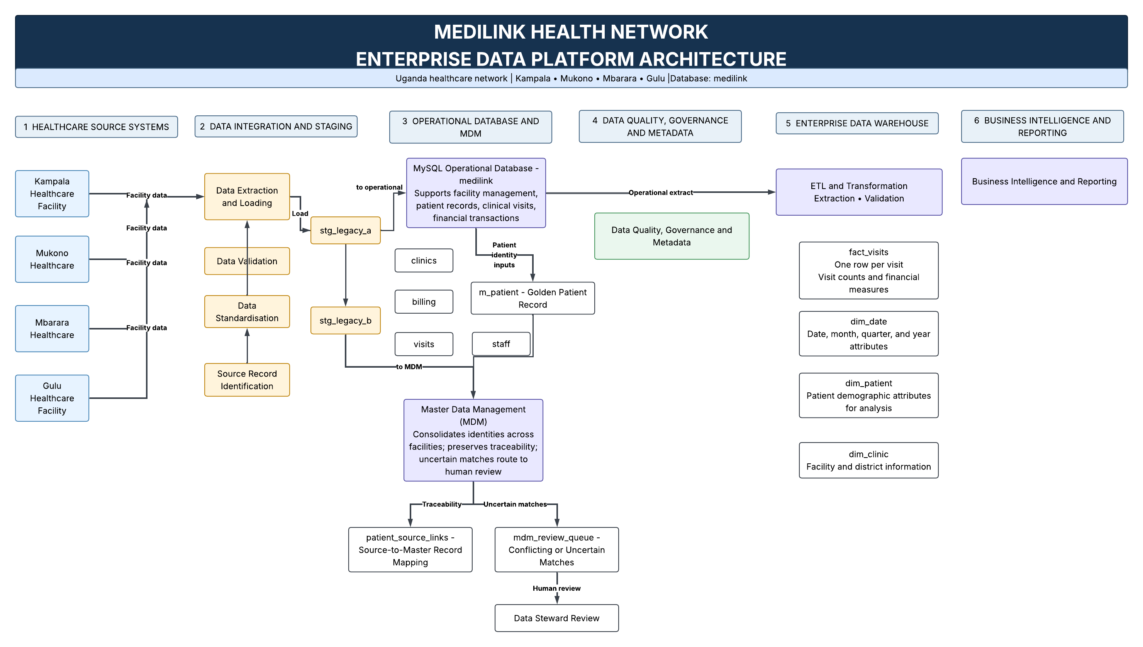

Medilink Entity Relationship Diagram
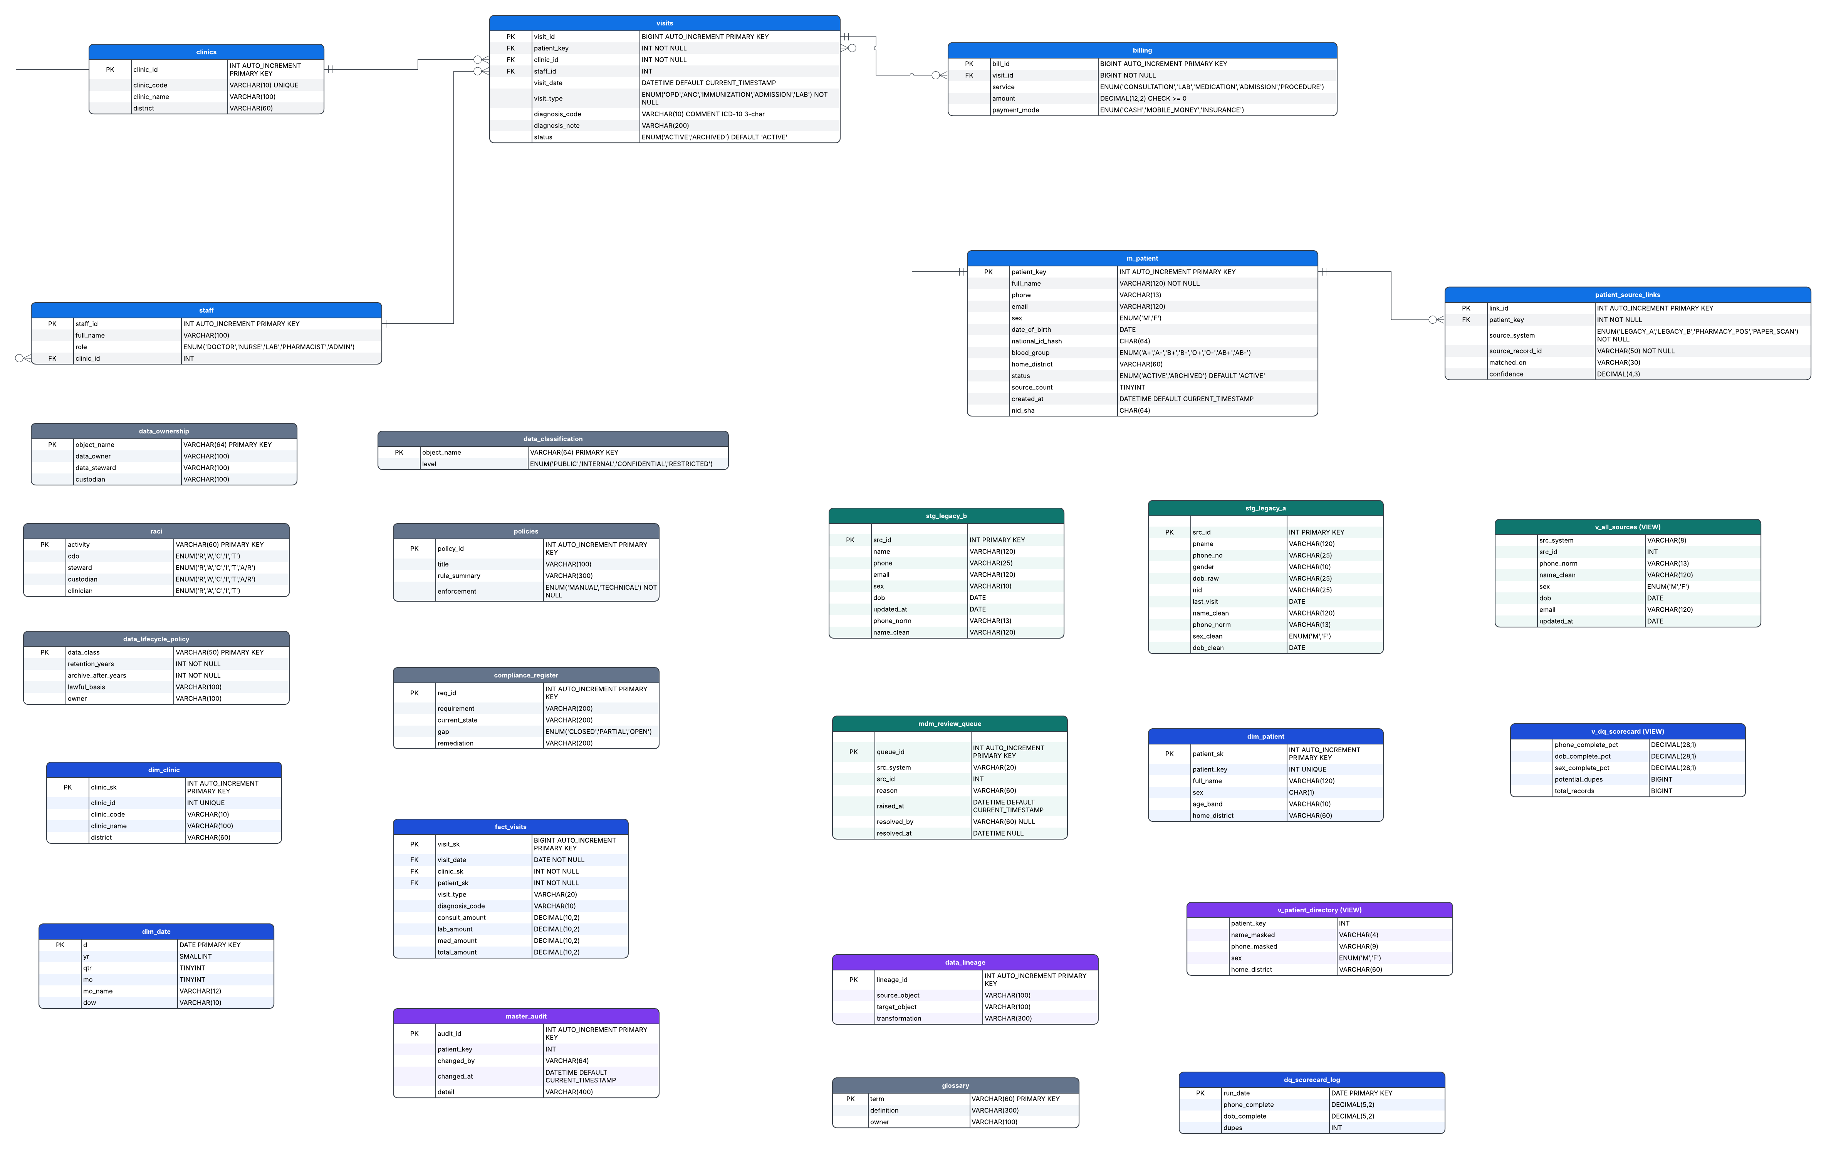

5. Data Quality Management

5.1 Data quality risks
The seed data illustrates several recurring quality issues: inconsistent name casing and spacing, multiple telephone formats, invalid placeholder values, inconsistent sex labels, incomplete dates of birth, missing email addresses and missing or inconsistent National ID values. These defects can cause duplicate records, failed joins, inaccurate reporting and avoidable manual work.
The data quality process should profile source records before cleaning, retain the raw fields for traceability, write standardized values to separate columns, validate those values, and then monitor the master data on a schedule. Records that cannot be corrected safely should be flagged for review rather than populated with guessed values.

5.2 Cleaning rules
Field | Rule | Handling when the value is uncertain
Name | Trim leading and trailing spaces and standardize presentation for display. | Do not assume similarly named people are the same person.
Telephone | Remove non-digit characters and normalize valid Ugandan numbers to 256XXXXXXXXX. | Set invalid or ambiguous values to NULL in the clean field and flag them for review.
Sex | Map recognized variants such as M, Male, F and Female to the approved M/F domain. | Leave unrecognized values unresolved and log the issue.
Date of birth | Parse supported formats such as YYYY-MM-DD and DD/MM/YYYY into DATE. | Do not invent a date when parsing fails.
National ID | Hash the value using SHA-256 during controlled ingestion and avoid plaintext in the trusted master. | Restrict access to any legacy plaintext while migration and deletion are managed.
Email | Trim whitespace and validate basic structure before accepting it. | Preserve NULL when no valid value is available.
Duplicates | Use normalized telephone as the primary matching key, with supporting evidence and steward review. | Do not automatically merge identity conflicts.

5.3 Measurement and targets
The project sets two primary master-data targets: at least 97% telephone completeness and zero invalid telephone numbers, measured weekly and logged. Additional useful measures include date-of-birth completeness, sex-domain consistency, duplicate candidates, unresolved MDM queue items and the number of rejected or corrected source rows.
Metric | Definition | Target or reporting requirement | Actual result
Telephone completeness | Master records with a non-null normalized phone divided by all master records, multiplied by 100. | At least 97%. | [Enter verified result]
Invalid telephone count | Records with a phone that fails the 256 plus nine digits validation rule. | 0. | [Enter verified result]
Date-of-birth completeness | Master records with a non-null date_of_birth divided by all master records, multiplied by 100. | Monitor and report weekly. | [Enter verified result]
Potential duplicate count | Candidate duplicates identified by the implemented duplicate-check rule. | Investigate and resolve; do not treat the count as confirmed duplicates without review. | [Enter verified result]
Open MDM review items | Number of unresolved records in mdm_review_queue. | Review regularly and assign an owner. | [Enter verified result]
Rejected source rows | Rows held because they fail validation or cannot be safely matched. | Track by source and reason. | [Enter verified result]

The brief provides an example of phone completeness changing from 71% to 100%, but these figures are illustrative and should not be reported as the group's achieved results unless the actual database queries return those values. The scorecard view v_dq_scorecard should be corrected and tested before use. Its calculations must use valid SQL syntax and a correct denominator, and its output should be saved in dq_scorecard_log for each scheduled run.

5.4 Root-cause analysis and monitoring
A fishbone analysis should consider people, process, technology, source design and governance. Possible causes include free-text entry, absence of a common phone validation rule, inconsistent date formats, migration without mapping rules, unclear ownership and a lack of regular feedback to source users. These are hypotheses to assess against the group's source inventory and sample data, not findings to assert without evidence.
The monitoring plan should run the same checks each week, compare the results with targets, assign a responsible owner to each failure and record corrective action. The data steward should review quality trends and recurring defects with the relevant source owner. The IT custodian should ensure that the queries and scheduled event run successfully and that failed runs are visible rather than silently ignored.

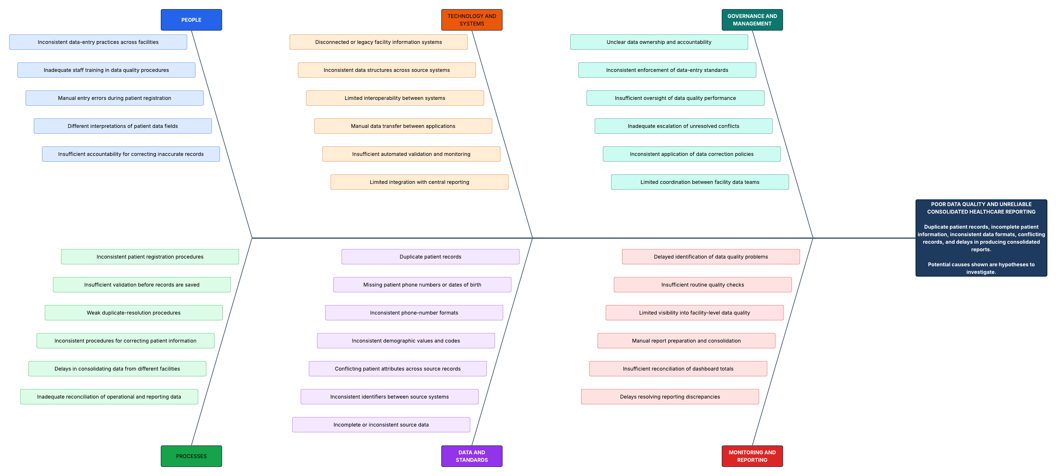

6. Master Data Management

6.1 Purpose and matching strategy
MDM creates a consistent patient identity across the source systems without discarding the source history. The primary matching key is the normalized telephone number, as specified in the brief. Name matching alone is not sufficient because names can be entered with different casing, spacing, abbreviations or spelling. Telephone matching is also imperfect: a family may share a number, a number may be changed or recycled, and a source may contain an invalid value. The matching process therefore needs a review path and a record of how each match was made.
The MDM process uses the staging tables stg_legacy_a and stg_legacy_b, standardizes the source fields, combines eligible records through v_all_sources, and creates a golden record in m_patient. patient_source_links records the relationship between each source record and the master patient. The mdm_review_queue holds records that cannot be matched safely or that require human judgment.

6.2 Survivorship rules
Field | Survivorship rule | Reason and safeguard
Telephone | Use the normalized valid number as the primary match key; for the surviving contact value, use the most recently updated eligible source. | Supports matching while preventing invalid values from becoming trusted identifiers.
Email | Use the most recently updated eligible source with a valid value. | Email may be missing from some systems, so a newer valid value should not be replaced by an empty field.
Full name | Do not silently merge conflicting identity values; refer material conflicts to the steward. | Different spellings may refer to the same person, but identical names may also belong to different people.
Date of birth | Use a consistent parsed date only when supported; send conflicts to review. | A wrong date may cause clinical and reporting errors.
Sex | Normalize known values to the approved domain; refer conflicting or unknown values to review. | Prevents inconsistent labels from being treated as distinct categories.
National ID | Store a SHA-256 hash in the master, not plaintext. | Reduces exposure of the raw identifier; the hash still requires protection.
Source links | Retain each source-system name and source record ID linked to the golden record. | Allows traceability, correction and investigation.
Unmatched records | Place unresolved rows in mdm_review_queue with a reason and resolution fields. | Prevents silent loss or unsafe merging.

The brief's Sarah Nakato example expects source rows 1 and 2 from Legacy A and row 101 from Legacy B to resolve to one master record where the matching and survivorship checks support that decision.

6.3 Review workflow
- Load source data into staging while preserving the original source identifiers.
- Normalize phone, name, sex and date-of-birth values in separate clean columns.
- Match records using valid normalized telephone numbers and calculate or record match confidence.
- Create or update a golden record only when the matching rule supports the decision.
- Send missing-phone cases, conflicting identity fields and uncertain matches to mdm_review_queue.
- Have the data steward review the evidence and record the resolution and reviewer.
- Maintain patient_source_links so each accepted source record remains traceable to its master.
- Run duplicate and crosswalk verification queries and save the results as implementation evidence.

7. Metadata, Cataloguing and Lineage
Metadata allows users to understand what data means, who is responsible for it, where it came from and how it has been transformed. The project brief states that every source system must register its owner, definitions and lineage in the catalog before it is trusted. This requirement is particularly important when staff change or when a new clinic joins the network.

7.1 Catalog components
Component | Implementation in the brief | Expected use
Technical data dictionary | Query information_schema.COLUMNS for the medilink schema, including data type and column comments. | Shows table structure and technical definitions.
Business glossary | glossary table containing terms such as Golden Record, OPD Attendance and Revenue. | Gives business users consistent meanings.
Lineage register | data_lineage table recording source_object, target_object and transformation. | Explains how staging and operational data feed master and warehouse objects.
Source inventory | Inventory of source name, owner, format, volume and quality reputation. | Supports source onboarding and trust decisions.
Impact analysis | One-page analysis of what depends on m_patient or another changed object. | Helps assess the consequences of schema or definition changes.

7.2 Example lineage
The brief describes a lineage path from stg_legacy_a and stg_legacy_b to m_patient through phone and name normalization, matching and survivorship. It also describes a path from visits and billing to fact_visits through joins to dimension tables and aggregation of billing amounts by service. These transformations should be recorded in data_lineage and checked against the SQL that actually runs.
The impact analysis should identify affected downstream objects if m_patient changes. Likely dependencies include patient_source_links, visits, dim_patient, fact_visits, views, data-quality queries and reports. The final impact statement should be confirmed by examining the implemented schema and queries.

8. Security, Privacy and Compliance

8.1 Data classification
The data_classification table records the sensitivity level assigned to each object. The sample classifies m_patient and visits as RESTRICTED, fact_visits as CONFIDENTIAL and dim_clinic as INTERNAL. The classification should be reviewed at column level where a table contains a mix of sensitive and less sensitive attributes. De-identification reduces exposure but does not automatically mean that all re-identification risk has disappeared.

8.2 National ID handling
The project rule is explicit: National ID must be stored as a SHA-256 hash only, never as plaintext in the trusted master. The migration procedure must be controlled so that the raw value is not copied into the master, logs or exported reports. Access to legacy source fields containing plaintext must be restricted while migration is completed, and any residual plaintext copies should be managed under an approved deletion and retention procedure. A hash of an identifier can still be personal data where it remains linkable to an individual, so the hashed value must still be protected.

8.3 Role-based access control
Role | Intended access | Database implementation referenced in the brief
ml_reception | Masked patient directory only. | SELECT on v_patient_directory.
ml_clinician | Full patient master data needed for clinical duties. | SELECT, INSERT and UPDATE on m_patient, subject to operational authorization.
ml_analyst | De-identified warehouse data only. | SELECT on fact_visits and approved dimensions or reporting views.
ml_auditor | Read access to the evidence required for audit. | Read-only grants restricted to approved objects.
The SQL examples in the brief should be checked before execution. In particular, the sample grant for ml_auditor has an incomplete object name, and the exact analyst grants should cover the required warehouse dimensions and reporting views without exposing direct identifiers. The sample account name and password should not be used as production credentials. Create named accounts with appropriate authentication and do not commit credentials to Git.

8.4 Masking and audit trails
The v_patient_directory view is intended to provide a masked name and phone number for reception users. Its output must be reviewed to ensure that it masks enough information to reduce unnecessary disclosure while still supporting the intended workflow. The master_audit table and trg_master_audit trigger are intended to record who changed a master record, when the change occurred and a summary of the change. Test updates should confirm that audit rows are written and that access to the audit data is restricted.

8.5 Billing immutability
The trg_billing_immutable trigger is intended to reject updates to existing billing rows with an error message instructing users to insert an adjustment instead. This supports the rule that billing rows are immutable. The final design should document the adjustment-row structure and ensure that users cannot bypass the rule through privileges or alternative procedures. A screenshot of an attempted update being rejected should be retained as evidence.

8.6 DPIA for SMS reminders
The proposed SMS reminder service may use a patient's contact number and limited appointment information. Before launch, MediLink should document the purpose, data fields, lawful basis, intended recipients, retention period, possible harm and safeguards. Messages should avoid disclosing diagnosis, HIV status or other sensitive clinical information on a lock screen or to a person who may share the telephone. Contact preferences and the process for handling incorrect numbers should be defined.
DPIA area | Assessment to complete
Purpose | Explain the specific service and why SMS reminders are needed.
Data used | List the phone number, reminder date and minimum appointment information required.
Lawful basis and transparency | Confirm the applicable lawful basis and how patients are informed.
Risks | Wrong-number disclosure, shared phones, message interception, excessive messaging and inaccurate contact data.
Mitigations | Use minimal message content, validate contact details, restrict access, log sending activity and provide a process for corrections or opting out where applicable.
Retention | Define how long reminder logs and contact preferences are retained.
Approval | Record review by the responsible data owner and privacy lead before the service is enabled.

8.7 Incident and breach response
The compliance register identifies the lack of a breach procedure as a gap. A breach playbook should define how staff report suspected disclosure, who triages the incident, how access is contained, how evidence is preserved, how impact is assessed, who decides on required notifications and how corrective action is recorded. Any notification deadline must be verified against applicable law and organizational policy. The final audit report should include evidence of the approved procedure and its owner.

8.8 Retention and lifecycle automation
The brief defines a 10-year clinical retention rule and shows a scheduled event named ev_archive_old_visits. It explicitly notes that the demonstration window is shortened and production retention is 10 years. The sample event uses a 10-day interval for demonstration, so it must not be represented as a production retention configuration. Test automation against synthetic or isolated test records, confirm the status transition, and document archive and authorized purge controls before considering production use.

9. Analytics and Ministry of Health Reporting

9.1 Reporting requirements
The Ministry of Health report should consolidate outpatient attendance, leading diagnoses and revenue by service, and be ready by the fifth day of each month. The warehouse is intended to reduce repeated manual extraction and make figures consistent across the four clinics. The SQL query pack should be the source of each dashboard chart so that the report can be reproduced and checked.

9.2 Required analysis
Analysis | Question answered | Required implementation check
Monthly attendance by clinic and district | How many visits occurred at each clinic and district each month? | Check date filters, roll-ups and the definition of OPD attendance.
Leading diagnoses | Which diagnosis codes account for the largest number of visits? | Use a clearly stated top-10 or top-5 limit consistent with the report requirement.
Revenue by service | How much revenue was recorded for consultation, laboratory, medication and other services? | Use actual billing service values and avoid double-counting visit-level totals.
Payment-mode mix | How is revenue distributed across cash, mobile money and insurance? | Retain payment_mode in the fact table or join it from an appropriate source; do not use a hard-coded placeholder.
Three-month moving average | How does monthly attendance trend over time? | Aggregate at month level first, then calculate the moving average.
Re-attendance within 30 days | What proportion of eligible patients returned within 30 days? | Define the denominator clearly and test the window-function query.

9.3 Dashboard and management finding
The project requires a dashboard chart for each query in Power BI or Tableau and a one-page management finding. Each chart should have a clear title, date range, measure, source and short interpretation. The management finding should state what the data shows, what operational decision it may support and any limitations in the data. Avoid interpreting a small or synthetic sample as a network-wide clinical trend.
The brief's sample SQL contains incomplete expressions and placeholder logic in several places, including aggregate functions, aliases and the payment-mode example. The queries must be corrected and tested against the implemented schema. Report only results generated by the actual database, and ensure that the figures shown in the dashboard reconcile to the SQL output.

10. Implementation Roadmap and Future Development

10.1 Implementation sequence
Stage | Work | Exit evidence
1. Foundation | Set up MySQL 8, Workbench, repository, source inventory and lifecycle policies. | Connection test, repository structure, inventory and lifecycle maps.
2. Governance and schema | Create governance registers, core relational tables, constraints and source staging. | Successful schema build, ERD and referential-integrity checks.
3. Data quality and MDM | Profile and clean source data, normalize telephone values, create golden records and review queue. | Before-and-after metrics, crosswalk query and steward-review examples.
4. Warehouse and metadata | Populate dimensions and fact table; document dictionary, glossary, lineage and ETL. | ETL workflow, warehouse row counts and catalog export.
5. Security and reporting | Apply role permissions, masking, audit triggers and billing protection; create SQL reports and dashboard. | Access tests, trigger tests, compliance evidence and dashboard outputs.
6. Automation and final review | Enable scheduled quality logging and lifecycle demonstration; compile strategy and rehearse presentation. | Event logs, completed evidence checklist, final report and 15-minute demonstration.

10.2 Cloud migration
A future cloud option could use a managed MySQL service to reduce the burden of database patching, backups and availability management. The decision should compare recurring cost, data residency and contractual requirements, connectivity at the clinics, recovery objectives, integration needs, staff capacity and vendor dependence. A managed service does not remove MediLink's responsibility for access control, data quality, privacy, retention and governance. The group should present this as a roadmap option, not as an implemented feature.

10.3 Data mesh opportunities
If the network grows, each clinic could be treated as a domain responsible for the quality and meaning of its operational data. This would not remove the need for shared patient identity rules, common definitions and central privacy controls. Any domain approach should preserve the central MDM rules and require new sources to complete catalog registration before their data is trusted.

10.4 Artificial intelligence candidates
The brief identifies automated diagnosis coding as a possible future use. It should remain exploratory until the network has reliable diagnosis data, an agreed coding standard, appropriate clinical review and a process for measuring errors. Any model should assist authorized staff rather than silently replace clinical judgment. Patient information should not be sent to external services without a documented lawful basis, security review and approved data-processing arrangements.

11. Operations, Monitoring and Risk Management

11.1 Routine operation
- Review the weekly data quality scorecard and assign actions for failed checks.
- Review unresolved MDM queue items and confirm that identity conflicts are resolved by an authorized steward.
- Check ETL row counts, rejected records and warehouse reconciliation before publishing monthly figures.
- Review database accounts and role assignments when staff responsibilities change.
- Check master_audit for unexpected changes and investigate anomalies.
- Confirm that scheduled events run, that event failures are visible and that logs are retained.
- Test backups and recovery procedures before relying on the platform for operational reporting.
- Review catalog entries when source definitions, schema fields or transformations change.

11.2 Key risks and mitigations
Risk | Possible consequence | Mitigation
Incorrect patient merge | Clinical information is attributed to the wrong person. | Use normalized identifiers, avoid silent identity merges, retain crosswalks and require steward review for conflicts.
Invalid or shared telephone number | Failed matching or disclosure to the wrong recipient. | Validate phone formats, flag ambiguous values and confirm contact details before SMS use.
Unauthorized access | Disclosure of sensitive personal or clinical data. | Use least privilege, masked views, named accounts, access reviews and audit logs.
Poor source metadata | Unclear definitions and untraceable data quality issues. | Require catalog registration and ownership before accepting a source as trusted.
ETL failure or duplicate loads | Missing or double-counted visits and revenue. | Use controlled load order, validation checks, reconciliation and repeatable load procedures.
Incorrect revenue query | Misleading financial reports. | Use service-level billing data, test aggregates and reconcile totals to source billing.
Retention job misconfiguration | Premature archiving or failure to retain records. | Separate test and production schedules, verify retention rules and require authorized review.
Staff turnover | Loss of undocumented knowledge and inconsistent decisions. | Maintain glossary, lineage, governance roles and a documented handover process.
Growth in data volume | Slower staging, matching and reports. | Measure performance, index join and filter fields, review load strategy and assess scaling needs.

11.3 Performance and scale
If volume increases substantially, the first bottleneck should be identified from measurement rather than assumed. Staging loads may be affected by validation and transformation costs, MDM by matching and review volume, and reporting by joins and aggregation. The technical response may include indexing, batch processing, incremental ETL, query optimization, archiving, and capacity planning. The group should identify likely bottlenecks from test results and state what additional evidence would be needed to confirm them.

12. Conclusion
The MediLink project addresses a connected set of data problems: duplicate patient identities, inconsistent source values, unclear accountability, privacy exposure and slow reporting. The proposed platform brings these concerns into one lifecycle. Governance establishes ownership and policies; staging and data quality checks standardize incoming records; MDM establishes a traceable golden record; the warehouse supports consistent reporting; metadata explains meaning and lineage; and security and automation controls reduce the chance that the rules depend only on staff remembering them.

Appendix A. Database Objects Referenced in the Design
The project brief contains the following principal database objects. The list summarizes their intended purpose; it is not confirmation that every object has been successfully created in the current environment.
Object | Type | Purpose
medilink | Database | Project database.
data_lifecycle_policy | Table | Retention, archive timing, lawful basis and owner by data class.
data_ownership | Table | Data owner, steward and custodian register.
Raci | Table | Responsibilities for governance activities.
policies | Table | Policy register.
compliance_register | Table | Compliance requirements, gaps and remediation.
clinics | Table | Clinic master.
Staff | Table | Staff and clinic relationships.
m_patient | Table | Golden patient master.
patient_source_links | Table | Source-to-master crosswalk.
Visits | Table | Operational visit records.
billing | Table | Service charges and payment mode.
stg_legacy_a | Table | Legacy A source staging.
stg_legacy_b | Table | Legacy B source staging.
mdm_review_queue | Table | Unmatched or conflicting records awaiting review.
dim_clinic | Table | Clinic warehouse dimension.
dim_patient | Table | De-identified patient warehouse dimension.
dim_date | Table | Calendar dimension.
fact_visits | Table | Visit and billing measures for analytics.
glossary | Table | Business definitions.
data_lineage | Table | Source-to-target transformation lineage.
data_classification | Table | Sensitivity classification by object.
master_audit | Table | Master-data change audit trail.
dq_scorecard_log | Table | Scheduled quality metric history.
v_dq_scorecard | View | Master data quality measures.
v_all_sources | View | Union of standardized source records.
v_patient_directory | View | Masked patient directory.
fill_dim_date | Procedure | Populates the date dimension.
trg_billing_immutable | Trigger | Rejects updates to existing billing rows.
trg_master_audit | Trigger | Writes master changes to master_audit.
ev_nightly_dq | Event | Logs daily data quality results.
ev_archive_old_visits | Event | Demonstrates scheduled archiving.

The brief also defines four roles: ml_reception, ml_clinician, ml_analyst and ml_auditor. It includes one sample database user, agnes, which should be treated as an example rather than a recommended shared or production account.

Appendix C. Individual Reflection and Contribution Log
Each group member should complete a separate reflection and contribution record. The final submission should not invent contributions on behalf of a member. The following editable table can be duplicated for each person.
Field | Member response
Name and registration number | KASIMAGWA STEVEN, 2024-08-29341
Assigned role | IT Custodian
Deliverables completed | Database setup, access controls and security configuration.
Evidence of contribution | SQL scripts, configuration screenshots and test results.
Main technical or governance challenge | Protecting sensitive patient data while allowing authorized access.
How the challenge was addressed | Configured access controls and checked permissions.
What was learned | Database administration, access control and data security.
Remaining limitations | Some security controls require further testing.

Field | Member response
Name and registration number | RWOTHONGEYO MARK, 2024-08-30835
Assigned role | Analyst
Deliverables completed | Data quality analysis, SQL queries and reporting requirements.
Evidence of contribution | SQL scripts, analysis results and dashboard outputs.
Main technical or governance challenge | Ensuring consistent reports across facilities.
How the challenge was addressed | Defined reporting measures and validated results using SQL.
What was learned | Data quality analysis, SQL and business intelligence.
Remaining limitations | Some dashboard figures require further validation.

Field | Member response
Name and registration number | AHAIRWE APOPHIA, 2024-08-31393
Assigned role | Data Steward
Deliverables completed | Data quality rules, patient matching and golden record requirements.
Evidence of contribution | Data quality rules, scorecards and duplicate review records.
Main technical or governance challenge | Avoiding incorrect merges of patient records.
How the challenge was addressed | Applied standardization rules and identified records requiring review.
What was learned | Master Data Management and data stewardship.
Remaining limitations | Some duplicate records may require further review.
Field | Member response
Name and registration number | BALABA CHARLES MOSES, 2024-08-29007
Assigned role | Data Steward
Deliverables completed | Data governance standards, validation rules and quality monitoring.
Evidence of contribution | Validation rules, quality reports and governance documentation.
Main technical or governance challenge | Maintaining consistent data quality across sources.
How the challenge was addressed | Documented quality rules and procedures for resolving exceptions.
What was learned | Data governance, validation and quality monitoring.
Remaining limitations | Some issues require further testing and governance approval.

Field | Member response
Name and registration number | MUSIMBI AARON, 2024-08-28258
Assigned role | Documenter
Deliverables completed | Technical documentation, diagrams and governance report sections.
Evidence of contribution | Report drafts, diagrams and document revision history.
Main technical or governance challenge | Ensuring documentation accurately reflects the implementation.
How the challenge was addressed | Reviewed project outputs and distinguished implemented controls from recommendations.
What was learned | Technical documentation, data lineage and evidence-based reporting.
Remaining limitations | Some sections require final verification against project outputs.

Reference
MediLink Health Network Enterprise Data Platform. Enterprise Data Management capstone project brief supplied for the course. [Mr Niyibizi Kenneth, Kampala International University, 2026]

